**Little's MCAR Test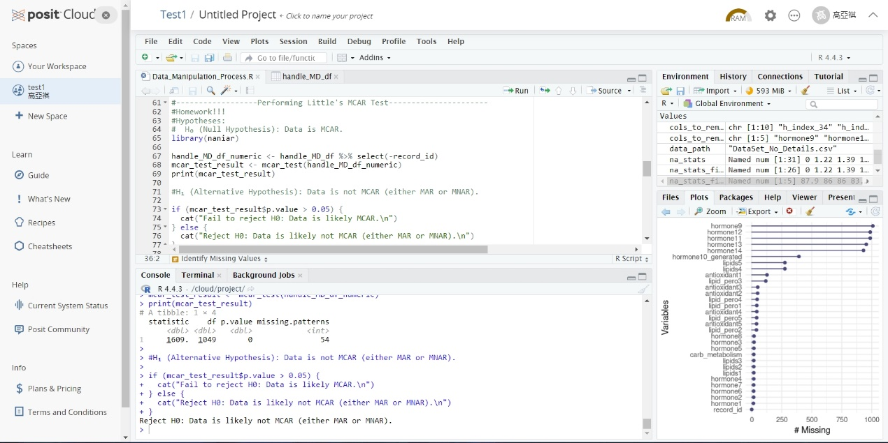method = 'pmm'****method = 'rf'**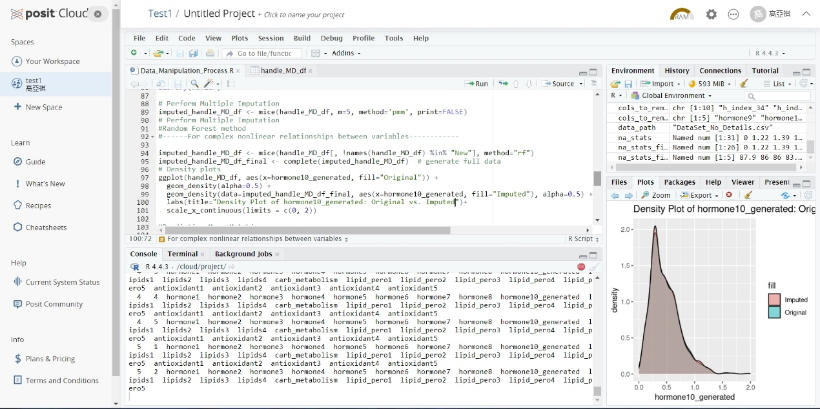 Based on the above analysis, we can draw the following conclusions:

• The "rf" method is better than the "pmm" method in this missing value interpolation: From the density plot, it can be seen that the data interpolated by the "rf" method is closer to the distribution of the original data, especially in some key areas, the difference between the interpolated data and the original data is very small. This shows that the "rf" method can better preserve the characteristics and distribution of the original data when dealing with missing values, thereby providing more accurate interpolation results.

**Calculating LOF factors**

